**Processing whole blood in Smart Tubes with Lyospheres**

1. Allow Smart Tube pouch to equilibrate to room temperature prior to processing.

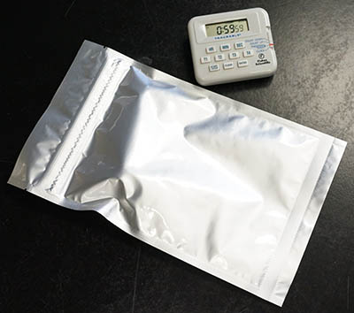

1. Open Smart Tube pouch. Each pouch contains 3 Smart Tubes, each of which is labeled at the top of the tube, just under the cap, according to the substance contained in the lyosphere:
   1. 001: Excipient only
   2. 020: Interferon Alpha (IFNα)
   3. 300: Lipopolysaccharide (LPS)

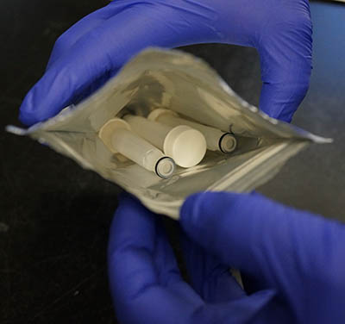 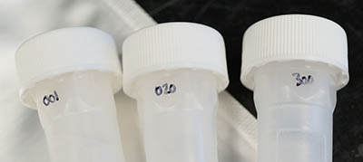

1. Label Smart Tubes appropriately. Label the side of the tube with a marker and affix a pre-made label to the other side. Secure pre-made label with clear tape to ensure it does not fall off during cryogenic storage.

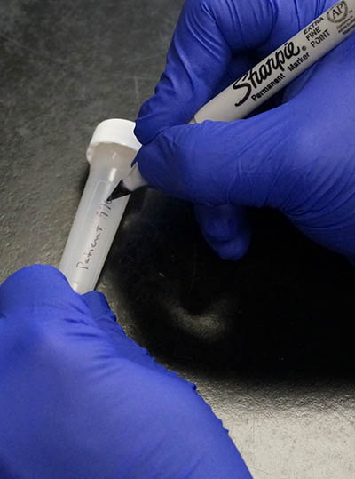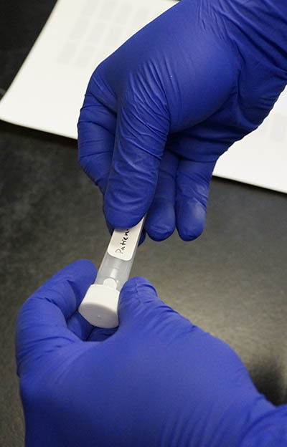

1. Draw peripheral venous blood into a sodium-heparin blood collection tube (BD catalog # 366480).
2. Store blood at room temperature until ready to process. Process blood within 1 hour of draw (within 30 minutes of draw for best results).

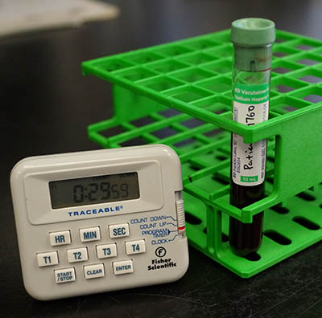

1. Open each Smart Tube and remove the small plastic insert with the loop using forceps, making sure the lyosphere stays inside the tube.

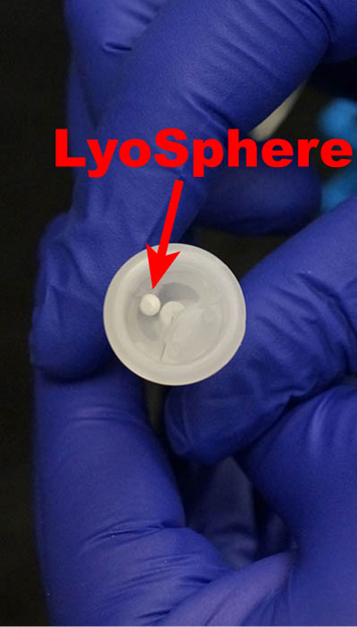 

1. Rotate/gently shake the tube so the lyosphere falls into the tube through the hole created by removing the insert.
2. Invert blood collection tube 5 times to ensure proper cell suspension. Dispense **900μL** blood into each Smart Tube.

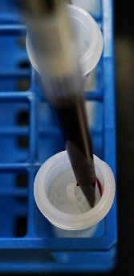

1. Cap each Smart Tube, and gently shake the tube while inverting several times to ensure complete mixing.

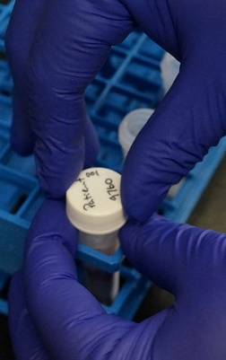

1. Incubate the Smart Tubes at 37°C for 15 minutes (use a water bath for best results).



1. Remove the Smart Tubes from the water bath and break the stabilizer-filled ampoule inside by squeezing and bending the tube.



1. Shake the tube gently, but firmly to mix the blood with the stabilizer.



1. Incubate blood with stabilizer for 10 minutes at room temperature.

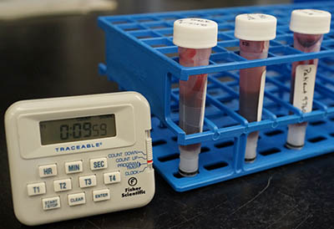

1. **Immediately** freeze the Smart Tubes at -80°C. If you cannot store the tubes immediately, keep them on ice until you can, but no more than 15 minutes. **Do not allow over-fixation!**

